LAB 1

- Check Java Compiler Version and Java Interpreter Version installed
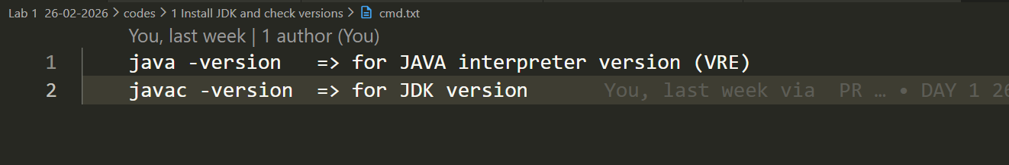
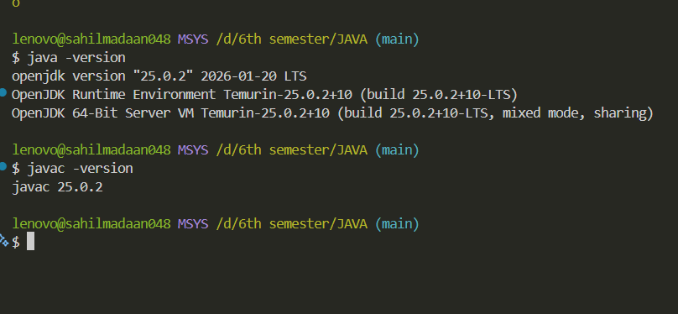

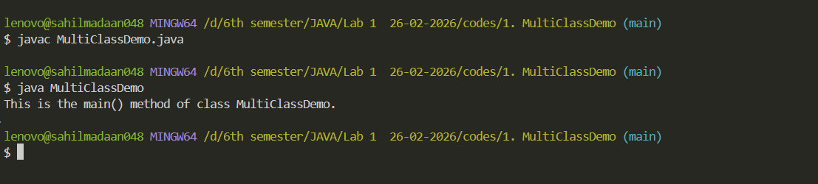

LAB 1

- Create a Java source file named MultiClassDemo.java that contains three classes

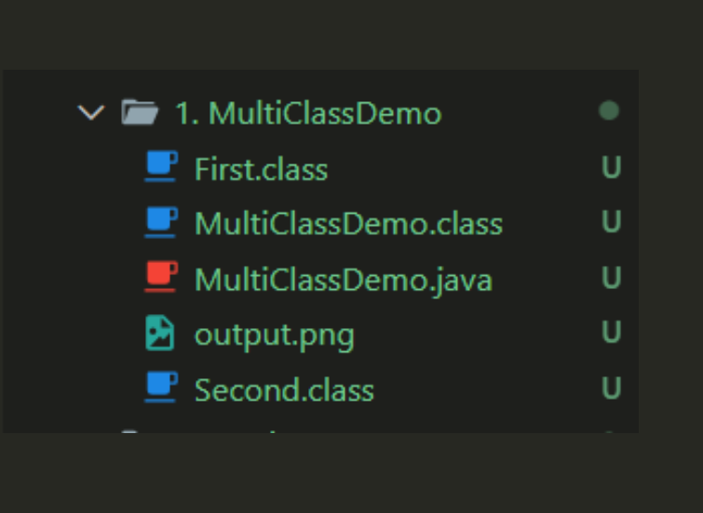

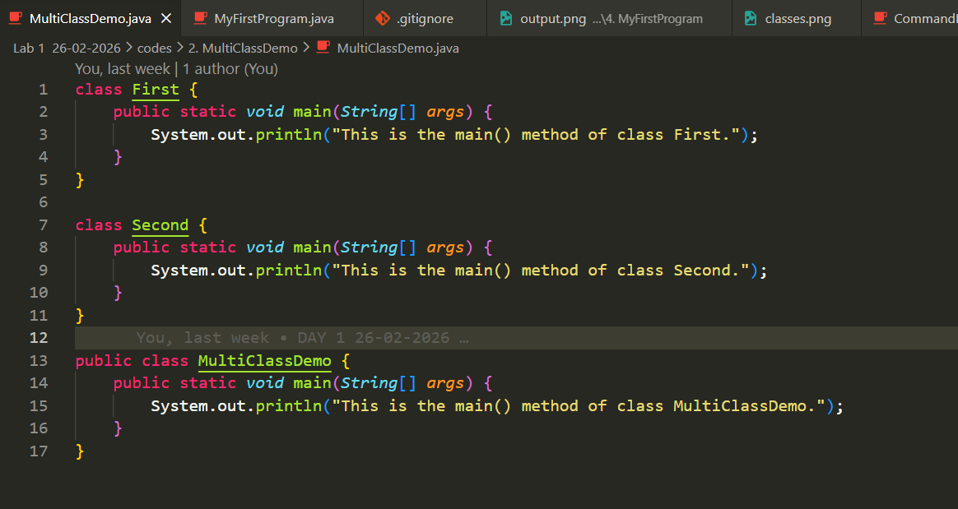

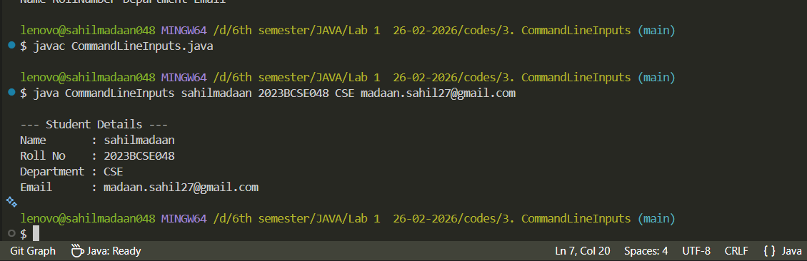

LAB 1

- Create a program named MyFirstProgram.java to print:
o Your name
o Roll number
o Department
o Email
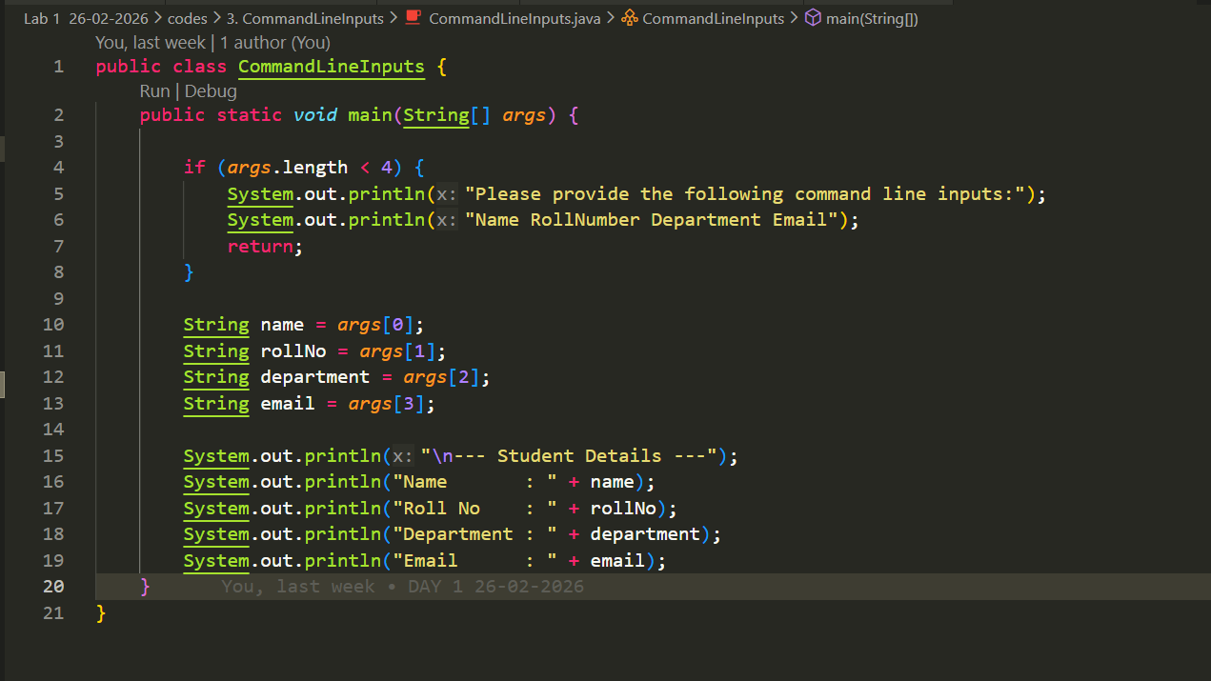

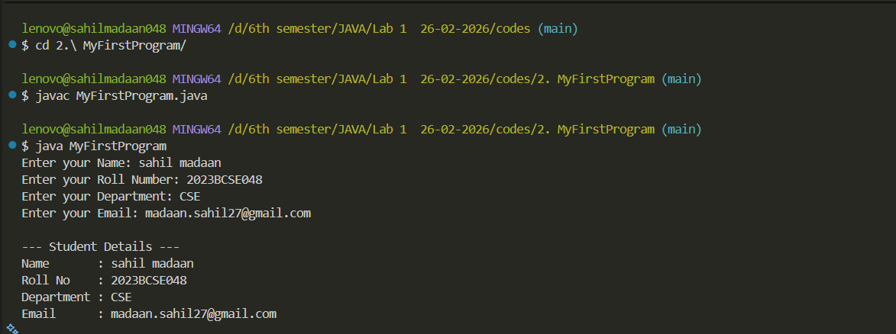

LAB 1

- Create a program to take the following as command line inputs from the user and printing them:
o Your name
o Roll number
o Department
o Email
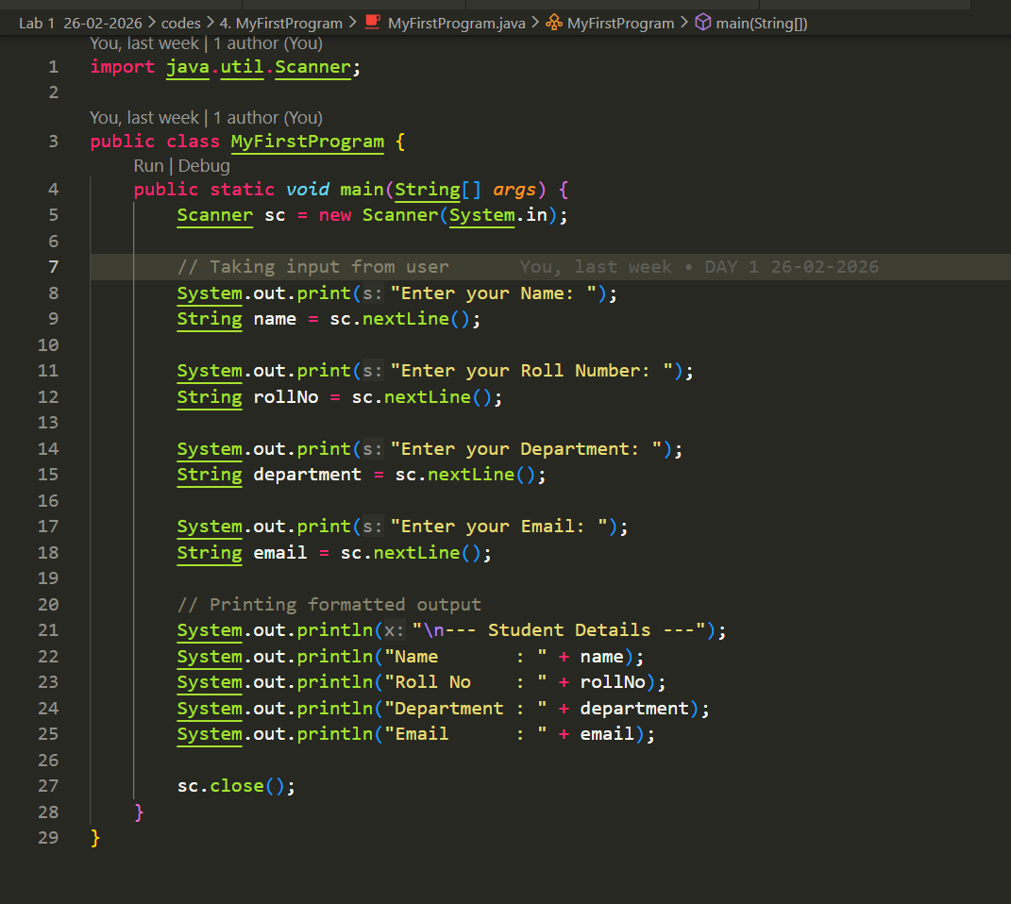

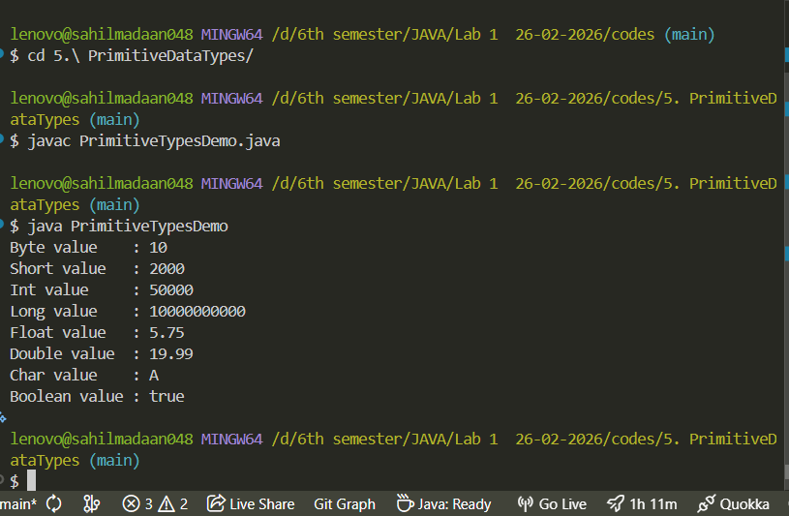

LAB 1

- . Write a Java program that declares variables of all primitive data types and prints their values. Use:
byte
short
int
long
float
double
char
boolean
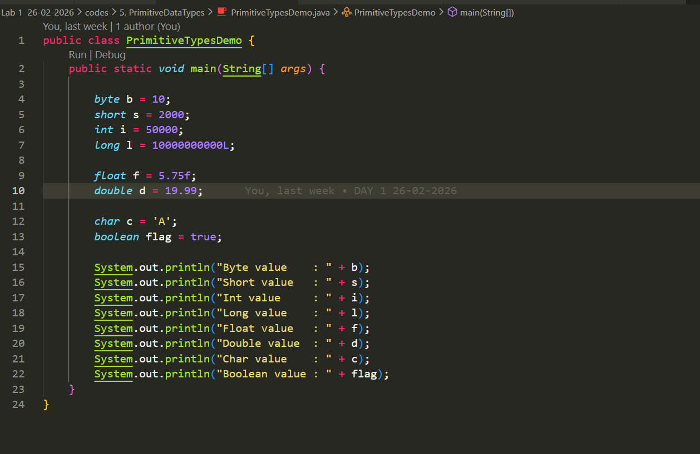

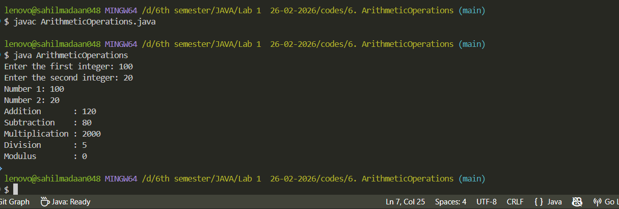

LAB 1
6. Write a program that:
Takes two integers (hardcoded)
Performs:
Addition
Subtraction
Multiplication
Division
Modulus
Prints all results.
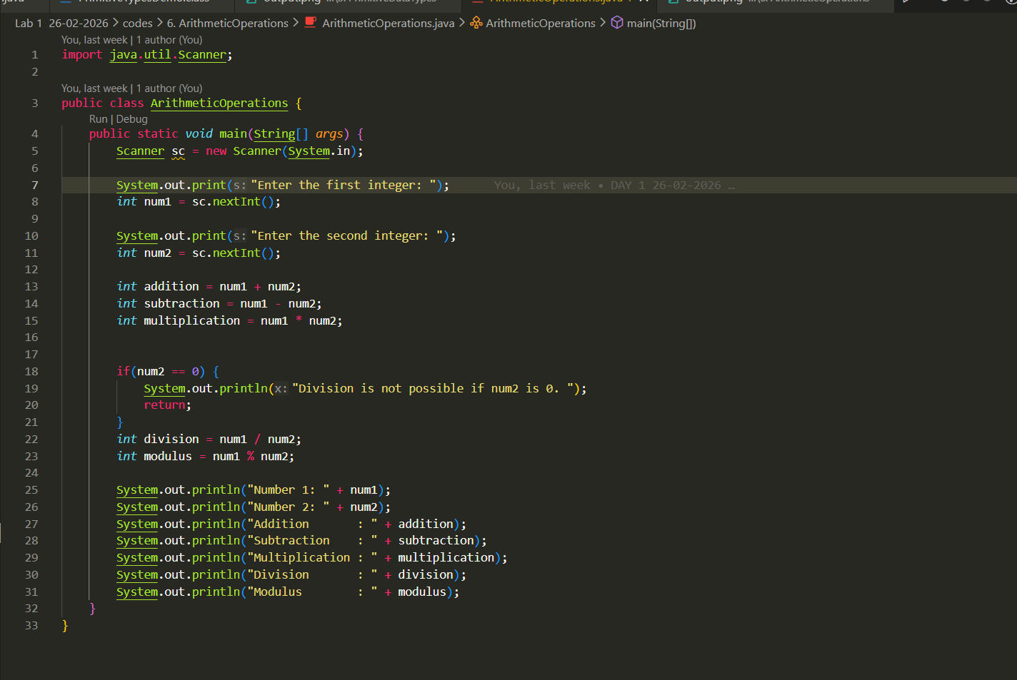

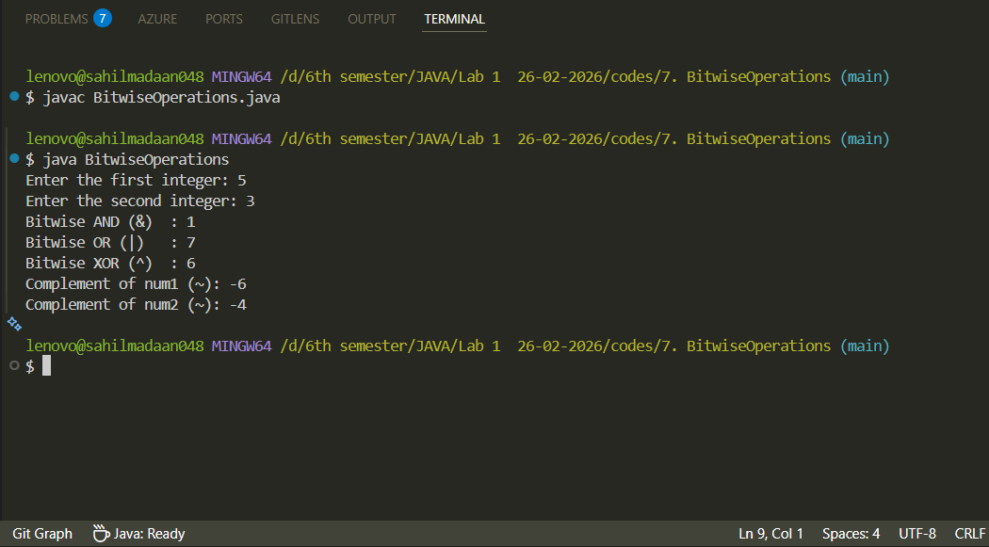

LAB 1
7. Write a program that:
Declares two integers and
Performs:
&
|
^
~

